2019-20

Name:
Enrollment Number:
Department: Electrical
Semester: 4th
Division (Batch):
COMPUTER AIDED ELECTRICAL DRAWING AND SIMULATION (3340905)

CERTIFICATE
This is to certify that term work embodied in this COMPUTER AIDED ELECTRICAL DRAWING AND SIMULATION (3340905) lab manual was carried out by
Mr / Mrs:
Enrollment No.:
Studying at Government Polytechnic, Rajkot (620) for partial fulfilment of Diploma Electrical Engineering degree to be awarded by Gujarat Technological University. This term work has been carried out under my guidance and supervision and it is up to my satisfaction.

Date:  Place: Rajkot |  | Sign:
Electrical Engineering Department,
Government Polytechnic,
Rajkot

GUJARAT TECHNOLOGICAL UNIVERSITY, AHMEDABAD, GUJARAT

GOVERNMENT POLYTECHNIC, RAJKOT
ELECTRICAL ENGINEERING DEPARTMENT

COURSE TITLE: COMPUTER AIDED ELECTRICAL DRAWING AND
SIMULATION
(Course Code: 3340905)
4th Semester

COURSE OUTCOMES:

- Make use of computer aided drawing software for electrical-electronics circuits and electrical machine parts. (A)
- Utilize simulation software to simulate electrical & electronics circuits. (A)
- Design Printed Circuit Board (PCB) using PCB design software. (C)

Instructions for the students
A. Do’s
1. Attend the laboratory always in time
2. Attend in formal dress
3. Submit the laboratory record and observation in every lab session
4. Use the laboratory systems properly and carefully
5. Attend the lab with procedure for the experiment
6. Switch off the systems immediately after the completion of the experiment
7. Place the bags outside
8. Leave the footwear outside
B. Don’ts
1. Don’t make noise in the laboratory
2. Don’t miss handle lab system
3. Don’t use cell phone in the lab

INDEX
Sr. No. | Date | Practical Exercise | Page No. | Marks | Sign
1. |  | Draw electrical and electronics symbols using CAD software
2. |  | Draw D.C. and A.C. Machine parts using CAD software
3. |  | Simulate following different types of rectifier circuit using CAD software:  1. Single phase half wave rectifier  2. Single phase full wave rectifier  3. Single phase bridge rectifier
4. |  | Draw & Simulate R-C Couple Amplifier Circuit.
5. |  | Simulate three resistances in series circuit and find out voltage across each resistance.
6. |  | Simulate two resistances in parallel and find out voltage and current in each resistance.
7. |  | Simulate R-L series circuit and observe voltage waveforms across each component.
8. |  | Simulate R-C series circuit and observe voltage waveforms across each component.
9. |  | Simulate R-L-C series circuit and observe voltage waveforms across each component.
10. |  | Simulate R-L parallel circuit and observe current waveforms through each component.
11. |  | Simulate R-C parallel circuit and observe current waveforms through each component.
12. |  | Simulate R-L-C parallel circuit and observe current waveforms through each component.
13. |  | Simulate basic logic gates.  1. AND Gate  2. OR Gate  3. NOT Gate
14. |  | Using Simulation prove De Morgan’s Theorem.
15. |  | Using simulations prove that NAND gate is universal gate.
16. |  | Using simulations prove that NOR gate is universal gate.
17. |  | Using simulations prove half added and full adder circuit.
18. |  | Using simulations prove half subtractor and full subtractor.
19. |  | Simulate stair case wiring circuit.
20. |  | Develop P.C.B. layout for a given electrical circuit using proteus software.  1. 5V Power Supply  2. Water Level Indicator

Experiment – 1
Aim: Draw electrical and electronics symbols using CAD software
Objective:
After completing this experiment, you will be able to:
- Know the different electrical symbol
- Draw the different electrical symbol using AutoCAD
- Know the Computer Aided Drawing (CAD) software

Apparatus:
- Computer System with AutoCAD software
Exercise:
Sr. No. | Name of Symbol | Symbol
1 | ELECTRICAL WIRE
2 | EARTH (GROUND)
3 | RESISTOR
4 | INDUCTOR
5 | CAPACITOR
6 | DIODE
7 | VOLTMETER
8 | AMMETER
9 | AC VOLTAGE SOURCE
10 | DC VOLTAGE SOURCE
11 | TRANSFORMER
12 | TRANSISTOR (NPN)
13 | THYRISTOR
14 | COMPARATOR
15 | AND GATE
16 | OR GATE
17 | NOT GATE
18 | NAND GATE
19 | NOR GATE
20 | EX-OR GATE

Questions:
- Why we use AutoCAD?
____________________________________________________________________________________________________________________________________________________________________________________________________________________________________________________________________________________
- State Different Menus of AutoCAD.
____________________________________________________________________________________________________________________________________________________________________________________________________________________________________________________________________________________
- Write the use of command window.
____________________________________________________________________________________________________________________________________________________________________________________________________________________________________________________________________________________
- Write the procedure to draw diode symbol.
____________________________________________________________________________________________________________________________________________________________________________________________________________________________________________________________________________________

Experiment – 2
Aim: Draw D.C. and A.C. Machine parts using CAD software
Objective:
After completing this experiment, you will be able to:
- Know the different machine parts
- Draw the different machine parts using AutoCAD
- Know the Computer Aided Drawing (CAD) software
Apparatus:
- Computer System with AutoCAD software
Exercise:

- D. C. Machine Pole Elevation

- Rotor Lamination of Induction Motor

Questions:
- Write the procedure to draw D. C. Machine Pole Elevation.
________________________________________________________________________________________________________________________________________________________________________________________________________________________________________________________________________________________________________________________________________________________________________________________________________________________________________________________________________________________________________________________________________________________________________

Experiment – 3
Aim: Simulate following different types of rectifier circuit using CAD software:
- Single phase half wave rectifier
- Single phase full wave rectifier
- Single phase bridge rectifier
Objective:
After completing this experiment, you will be able to:
- Simulate different rectifier circuit
- Analyse the output waveform
- Identify & Select suitable rectifier for your application
Apparatus:
- Computer System with PSIM software
Theory:
A rectifier is an electrical device that converts an Alternating Current (AC) into a Direct Current (DC) by using one or more P-N junction diodes.
Types of rectifiers:
The rectifiers are mainly classified into two types:
- Half wave rectifier
- Full wave rectifier

Half wave rectifier:
As the name suggests, the half wave rectifier is a type of rectifier which converts half of the AC input signal (positive half cycle) into pulsating DC output signal and the remaining half signal (negative half cycle) is blocked or lost. In half wave rectifier circuit, we use only a single diode.
The no-load output DC voltage of an ideal half-wave rectifier for a sinusoidal input voltage is:
$$V_{dc}= \frac{V_{peak}}{π}$$
Where:
V_{dc}: the DC or average output voltage,
V_{peak}: the peak value of the phase input voltages.

Full wave rectifier:
The full wave rectifier is a type of rectifier which converts the full AC input signal (positive half cycle and negative half cycle) to pulsating DC output signal. Unlike the half wave rectifier, the input signal is not wasted in full wave rectifier. The efficiency of full wave rectifier is high as compared to the half wave rectifier.
The average no-load output voltage of an ideal single phase full wave rectifier is:
$$V_{dc}= \frac{2×V_{peak}}{π}$$
Where:
V_{dc}: the DC or average output voltage,
V_{peak}: the peak value of the phase input voltages.

1. Single phase half wave rectifier:
Circuit Diagram:

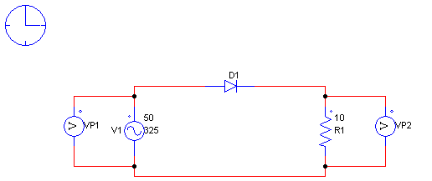
Output Waveform:

2. Single phase full wave rectifier
Circuit Diagram:
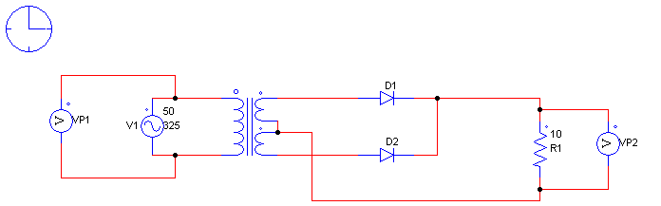
Output Waveform:

3. Single phase bridge rectifier
Circuit Diagram:
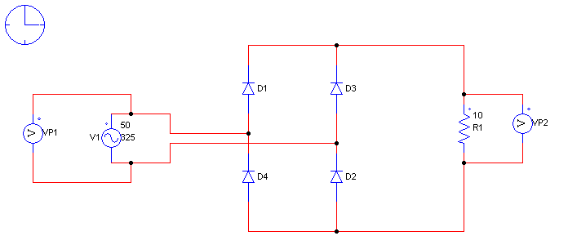

Output Waveform:

Procedure
- Open PSIM
- Open new file
- Drag all the components from menu and connect it with wire probe
- Add the simulation control from the simulate menu
- Save the file in current directory
- Run the simulation by pressing F8
- Observe the waveforms

Precaution:
- Don’t connect wires at the wire crossovers.

Calculation:
Output Voltage of Half wave rectifier:
$$V_{dc}= \frac{V_{peak}}{π}=$$
Output Voltage of Full wave rectifier:
$$V_{dc}= \frac{2×V_{peak}}{π}=$$

Conclusion:
________________________________________________________________________________________________________________________________________________________________________________________________________________________________________________________________________________________________________________________________________________________________________________________________________________________________________________________________________________________________________________________________________________________________________________________________________________________________________________________________________________________________________________________________________________________________________________________________________________________________________________________
Questions:
- What is the average output voltage of:
Half wave rectifier: ____________.
Full wave rectifier: ____________.
- Which rectifier gives higher output and efficiency? _____________.
- How many diodes are required in the single phase bridge rectifier? _____________.

Experiment – 4
Aim: Draw & Simulate R-C Couple Amplifier Circuit.
Objective:
After completing this experiment, you will be able to:
- Simulate R-C Couple Amplifier Circuit
- Analyse the output amplified waveform
Apparatus:
- Computer System with PSIM software.
Theory:
A Resistance Capacitance (RC) Coupled Amplifier is basically a multi-stage amplifier circuit extensively used in electronic circuits. Here the individual stages of the amplifier are connected together using a resistor–capacitor combination due to which it bears its name as RC Coupled.
Figure shows below such a two-stage amplifier whose individual stages are nothing but the common emitter amplifiers. Hence the design of individual stages of the RC coupled amplifiers is similar to that in the case of common emitter amplifiers in which the resistors R1 and R2 form the biasing network while the emitter resistor RE form the stabilization network. Here the CE is also called bypass capacitor which passes only AC while restricting DC, which causes only DC voltage to drop across RE while the entire AC voltage will be coupled to the next stage.
Further, the coupling capacitor CC also increases the stability of the network as it blocks the DC while offers a low resistance path to the AC signals, thereby preventing the DC bias conditions of one stage affecting the other. In addition, in this circuit, the voltage drop across the collector-emitter terminal is chosen to be 50% of the supply voltage V_{CC} in order to ensure appropriate biasing point.

Advantages of RC Coupled Amplifier
- Cheap, economical and compact as it uses only resistors and capacitors.
- Offers a constant gain over a wide frequency band.

Disadvantages of RC Coupled Amplifier
- Unsuitable for low-frequency amplification.
- Low voltage and power gain as the effective load resistance (and hence the gain) is reduced due to the fact that the input of each stage presents a low resistance to its next stage.
- Moisture-sensitive, making them noisy as time elapses.
- Narrow bandwidth when compared to JFET amplifier.

Applications of RC Coupled Amplifier
- RF Communications.
- Optical Fibre Communications.
- Public address systems as pre-amplifiers.
- Controllers.
- Radio or TV Receivers as small signal amplifiers.
Circuit Diagram:
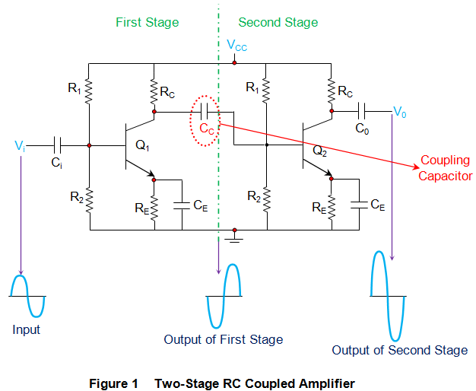
Output Waveform:

Conclusion:
________________________________________________________________________________________________________________________________________________________________________________________________________________________________________________________________________________________________________________________________________________________________________________________________________________________________________________________________________________________________________________________________________________________________________________________________________________________________________________________________________________________________________________________________________________________________________________________________________________________________________________________
Questions:
- What is the Working Procedure of an RC Coupled Amplifier?
_______________________________________________________________________________________________________________________________________________________________________________________________________________________________________________________________________________________________________________________________________________________________________________________________________________________________________________________________________________________________________________________________________________________________________________________________________________________________________________________________________________________________________________________________________________________________________________________

Experiment – 5
Aim: Simulate three resistances in series circuit and find out voltage across each resistance.
Objective:
After completing this experiment, you will be able to:
- Simulate series resistance circuit
- Analyse voltage across each resistance
Apparatus:
- Computer System with PSIM software.
Theory:
A series circuit is a circuit in which resistors are arranged in a chain, so the current has only one path to take. The current is the same through each resistor. The total resistance of the circuit is found by simply adding up the resistance values of the individual resistors:
Equivalent resistance of resistors in series: R = R₁ + R₂ + R₃ + ...
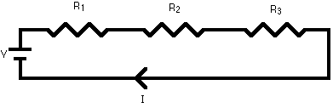
A series circuit is shown in the diagram above. The current flows through each resistor in turn. If the values of the three resistors are:
R₁ = 8Ω, R₂ = 8Ω, and R₃ = 4Ω, the total resistance is 8+8+4=20Ω.
With a 10 V battery, by V = I×R the total current in the circuit is:
$$I= \frac{V}{R}= \frac{10}{20}=0.5 A$$
The current through each resistor would be 0.5 A.

Circuit Diagram:
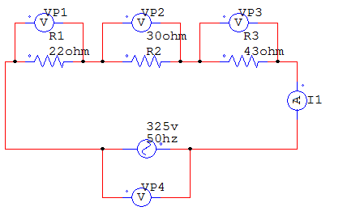
Output Waveform:
Sr. No. | Name | Waveform
1 | Supply  Voltage
2 | Total  Current
3 | Voltage Across R1
4 | Voltage Across R2
5 | Voltage Across R3

Calculation:
Voltage across each resistance by calculation:
VP1=
VP2=
VP3=

Conclusion:
________________________________________________________________________________________________________________________________________________________________________________________________________________________________________________________________________________________________________________________________________________________________________________________________________________________________________________________________________________________________________________________________________________________________________________________________________________________________________________________________________________________________________________________________________________________________________________________________________________________________________________________
Questions:
- What will be the value of the I₁, if R₁ value set to 50 Ω: _________.
- What should be the value of R₁ to get the 100V across R₁: ________.
- Is frequency affect the voltage drop across the resistances: Yes / No

Experiment – 6
Aim: Simulate two resistances in parallel and find out voltage and current in each resistance.
Objective:
After completing this experiment, you will be able to:
- Simulate parallel resistance circuit
- Analyse current in each resistance
Apparatus:
- Computer System with PSIM software.
Theory:
Resistors are said to be connected together in parallel when both of their terminals are respectively connected to each terminal of the other resistor or resistors.
In a parallel resistor network the circuit current can take more than one path as there are multiple paths for the current. Then parallel circuits are classed as current dividers.
Since there are multiple paths for the supply current to flow through, the current may not be the same through all the branches in the parallel network. However, the voltage drop across all of the resistors in a parallel resistive network is the same. Then, Resistors in Parallel have a Common Voltage across them and this is true for all parallel connected elements.
So, we can define a parallel resistive circuit as one where the resistors are connected to the same two points (or nodes) and are identified by the fact that it has more than one current path connected to a common voltage source. Then in our parallel resistor example below the voltage across resistor R₁ equals the voltage across resistor R₂ which equals the voltage across R₃ and which equals the supply voltage. Therefore, for a parallel resistor network this is given as:
V_{R1} = V_{R2} = V_{R3} = V_{AB} = 12 V
In the following resistors in parallel circuit the resistors R₁, R₂ and R₃ are all connected together in parallel between the two points A and B as shown.
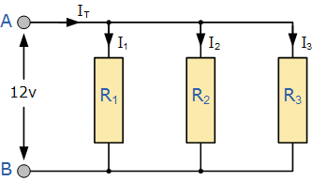
Here, the reciprocal ( 1/R ) value of the individual resistances are all added together instead of the resistances themselves with the inverse of the algebraic sum giving the equivalent resistance as shown.
$$\frac{1}{R_{T}}=\frac{1}{R_{1}}+ \frac{1}{R_{2}}+ \frac{1}{R_{3}}$$
As the supply voltage is common to all the resistors in a parallel circuit, we can use Ohms Law to calculate the individual branch current as follows.
For example, current passing in resistance R₁:
$$I_{1}=\frac{V_{S}}{R_{1}}$$
Circuit Diagram:
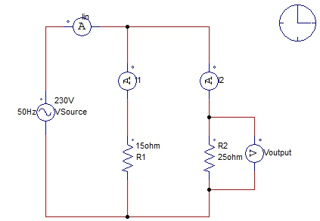
Output Waveform:
Sr. No. | Name | Waveform
1 | Supply  Voltage
2 | Total  Current
3 | Current Through R1
4 | Current Through R2
5 | Voltage Across R1
6 | Voltage Across R2

Calculation:
Current through each resistance by calculation:
I₁=
I₂=

Total Current:
I_{in}=

Conclusion:
________________________________________________________________________________________________________________________________________________________________________________________________________________________________________________________________________________________________________________________________________________________________________________________________________________________________________________________________________________________________________________________________________________________________________________________________________________________________________________________________________________________________________________________________________________________________________________________________________________________________________________________
Questions:
- What will be the value of the I₁, if R₁ value set to 20 Ω: _________.
- What should be the value of R₁ to get the 2A current through R₁: ________.
- Is frequency affect the current passing through the resistances: Yes / No

Experiment – 7
Aim: Simulate R-L series circuit and observe voltage waveforms across each component.
Objective:
After completing this experiment, you will be able to:
- Simulate R-L series circuit
- Analyse voltage waveforms across each component
Apparatus:
- Computer System with PSIM software.
Theory:
Consider a simple RL circuit in which resistor, R and inductor, L are connected in series with a voltage supply of V volts. Let us think the current flowing in the circuit is I (amp) and current through resistor and inductor is I_{R} and I_{L} respectively.
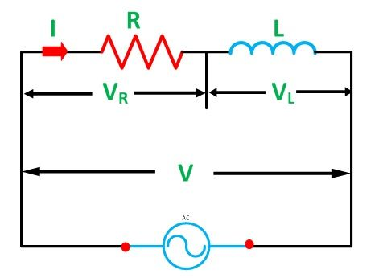
Since both resistance and inductor are connected in series, so the current in both the elements and the circuit remains the same. I.e. I_{R} = I_{L} = I. Let V_{R} and V_{L} be the voltage drop across resistor and inductor.
Applying Kirchhoff Voltage law (i.e. sum of voltage drop must be equal to apply voltage) to this circuit we get,
V = V_{R} + V_{L}
Relationship between voltage and current in case of resistor and inductor:
Resistor:
In case of resistor, the voltage and the current are in same phase or we can say that the phase angle difference between voltage and current is zero.
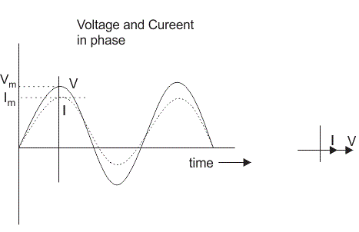
Inductor:
In inductor, the voltage and the current are not in phase. The voltage leads that of current by 90º or in other words, voltage attains its maximum and zero value 90º before the current attains it.
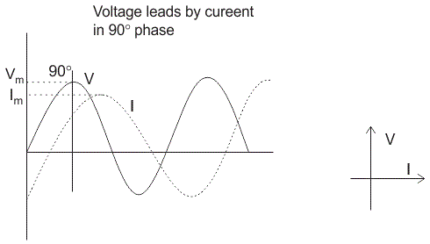
RL Circuit:
In case of pure resistive circuit, the phase angle between voltage and current is zero and in case of pure inductive circuit, phase angle is 90º but when we combine both resistance and inductor, the phase angle of a series RL circuit is between 0º to 90º.
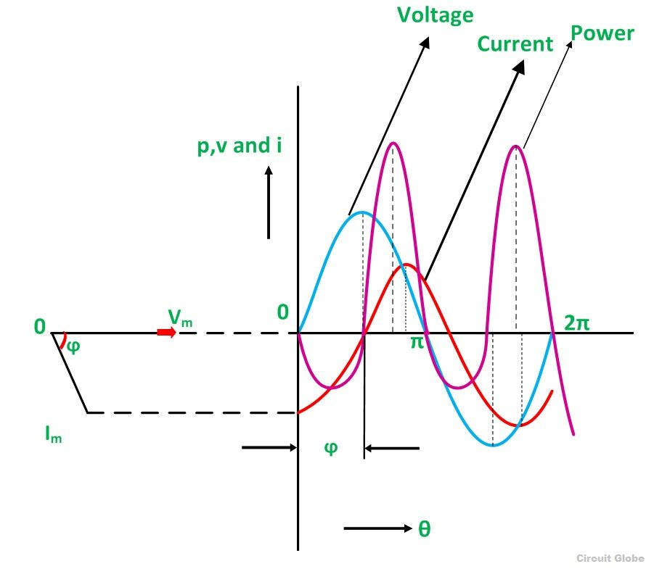
Circuit Diagram:
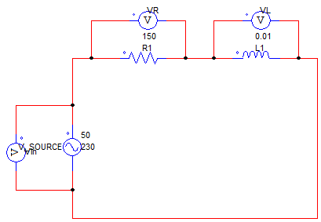
Output Waveform:
Sr. No. | Name | Waveform
1 | Supply  Voltage
2 | Supply  Current
3 | Voltage Across  R1
4 | Voltage Across  L1

Conclusion:
_____________________________________________________________________________________________________________________________________________________________________________________________________________________________________________________________________________________________________________________________________________________________________________________________________________________________________________________________________________________________________________________________________________
Questions:
- What will happen if value of resistance is increased?
________________________________________________________________________________________________________________________________________
- What will happen if value of inductor is increased?
________________________________________________________________________________________________________________________________________

Experiment – 8
Aim: Simulate R-C series circuit and observe voltage waveforms across each component.
Objective:
After completing this experiment, you will be able to:
- Simulate R-C series circuit
- Analyse voltage waveforms across each component
Apparatus:
- Computer System with PSIM software.
Theory:
A circuit that contains pure resistance R ohms connected in series with a pure capacitor of capacitance C farads is known as RC Series Circuit. A sinusoidal voltage is applied to and current I flow through the resistance (R) and the capacitance (C) of the circuit. The RC Series circuit is shown in the figure below:
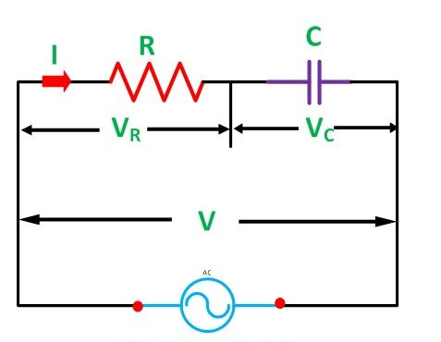
In RC series circuit current leads the voltage that can be seen in following waveforms.
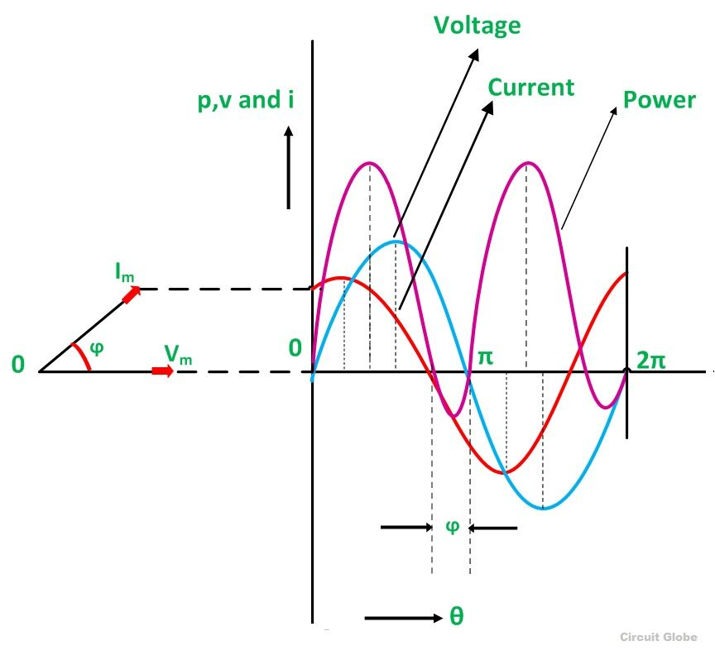
Circuit Diagram:
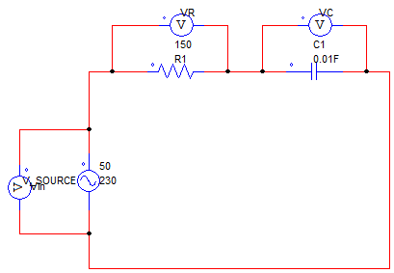
Output Waveform:
Sr. No. | Name | Waveform
1 | Supply  Voltage
2 | Supply  Current
3 | Voltage Across  R1
4 | Voltage Across  C1

Conclusion:
_____________________________________________________________________________________________________________________________________________________________________________________________________________________________________________________________________________________________________________________________________________________________________________________________________________________________________________________________________________________________________________________________________________
Questions:
- What will happen if value of resistance is increased?
________________________________________________________________________________________________________________________________________
- What will happen if value of capacitor is increased?
________________________________________________________________________________________________________________________________________

Experiment – 9
Aim: Simulate R-L-C series circuit and observe voltage waveforms across each component.
Objective:
After completing this experiment, you will be able to:
- Simulate R-L-C series circuit
- Analyse voltage waveforms across each component
Apparatus:
- Computer System with PSIM software.
Theory:
The RLC Series Circuit is defined as when a pure resistance of R ohms, a pure inductance of L Henry and a pure capacitance of C farads are connected together in series combination with each other. As all the three elements are connected in series so, the current flowing in each element of the circuit will be same as the total current I flowing in the circuit.
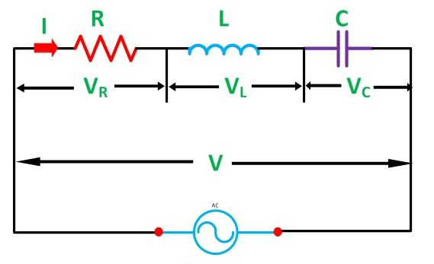
The three cases of RLC Series Circuit
- When X_{L} > X_{C}, the phase angle ϕ is positive. The circuit behaves as a RL series circuit in which the current lags behind the applied voltage and the power factor is lagging.
- When X_{L} < X_{C}, the phase angle ϕ is negative, and the circuit acts as a series RC circuit in which the current leads the voltage by 90 degrees.
- When X_{L} = X_{C}, the phase angle ϕ is zero, as a result, the circuit behaves like a purely resistive circuit. In this type of circuit, the current and voltage are in phase with each other. The value of power factor is unity.

Circuit Diagram:
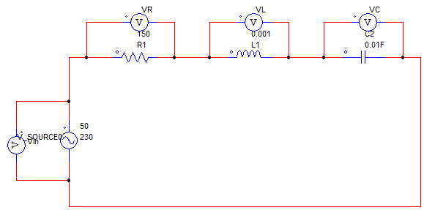
Output Waveform:
Case 1 : X_{L} > X_{C}
Sr. No. | Name | Waveform
1 | Supply  Voltage
2 | Supply  Current
3 | Voltage Across  R1
4 | Voltage Across  L1
5 | Voltage Across  C1

Case 2 : X_{L} < X_{C}
Sr. No. | Name | Waveform
1 | Supply  Voltage
2 | Supply  Current
3 | Voltage Across  R1
4 | Voltage Across  L1
5 | Voltage Across  C1

Case 3 : X_{L} = X_{C}
Sr. No. | Name | Waveform
1 | Supply  Voltage
2 | Supply  Current
3 | Voltage Across  R1
4 | Voltage Across  L1
5 | Voltage Across  C1

Conclusion:
_____________________________________________________________________________________________________________________________________________________________________________________________________________________________________________________________________________________________________________________________________________________________________________________________________________________________________________________________________________________________________________________________________________
Questions:
- What will happen the case of X_{L}>X_{C}?
________________________________________________________________________________________________________________________________________
- What will happen the case of X_{L}< X_{C}?
________________________________________________________________________________________________________________________________________
- What will happen the case of X_{L}= X_{C}?
________________________________________________________________________________________________________________________________________

Experiment – 10
Aim: Simulate R-L parallel circuit and observe current waveforms through each component.
Objective:
After completing this experiment, you will be able to:
- Simulate R-L Parallel circuit
- Analyse current waveforms
Apparatus:
- Computer System with PSIM software.
Theory:
In RL parallel circuit resistor and inductor are connected in parallel with each other and this combination is supplied by a voltage source (V_{in}). The output voltage of circuit is V_{out}. Since the resistor and inductor are connected in parallel, the input voltage is equal to output voltage but the currents flowing in resistor and inductor are different.
The parallel RL circuit is not used as filter for voltages because in this circuit, the output voltage is equal to input voltage and for this reason it is not commonly used as compared to series RL circuit.
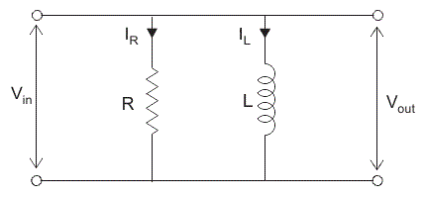
Let us say: I_{T} = the total current flowing from voltage source in amperes.
I_{R} = the current flowing in the resistor branch in amperes.
I_{L} = the current flowing in the inductor branch in amperes.
θ = angle between I_{R} and I_{T}.
So the total current I_{T}, $I_{T}^{2}= I_{R}^{2}+ I_{L}^{2}$
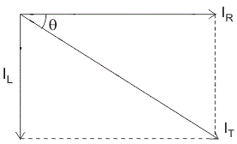
Circuit Diagram:
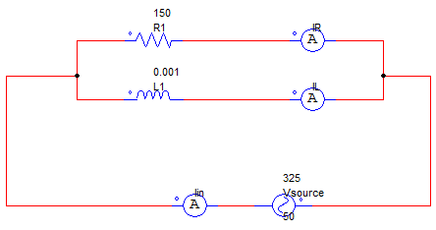
Output Waveform:
Sr. No. | Name | Waveform
1 | Supply  Voltage
2 | Supply  Current
3 | Current Through  R1
4 | Current Through  L1

Conclusion:
__________________________________________________________________________________________________________________________________________________________________________________________________________________________________________________________________________________________________________________________________________________________________________________________________________________________________________________________________________________________________________________________________________________________________________________________________________________________________________________________________________________________________________________________________________________________________________________________________________________________________________________________________________________________________________________________________________________________________________________________________________________________________________________________________________________________
Questions:
- What will happen if value of resistance is increased?
________________________________________________________________________________________________________________________________________
- What will happen if value of inductor is increased?
______________________________________________________________________________________________________________________________________

Experiment – 11
Aim: Simulate R-C parallel circuit and observe current waveforms through each component.
Objective:
After completing this experiment, you will be able to:
- Simulate R-C Parallel circuit
- Analyse current waveforms
Apparatus:
- Computer System with PSIM software.
Theory:
When AC is applied to the parallel RC circuit shown below the capacitor never reaches a final charge and therefore it will always carry some current.
To make matters more interesting, we know that the voltage in a parallel circuit must be the same throughout the circuit. However, the current through R is not the same as the current through C. Thus, IR is in phase with V, but IC leads V by 90°.
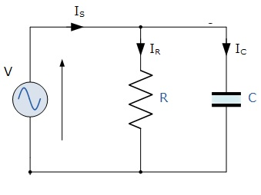
Circuit Diagram:
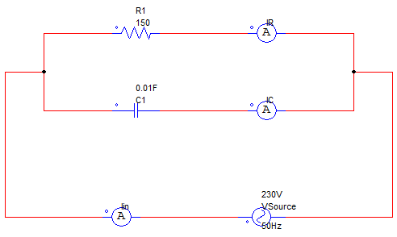
Output Waveform:
Sr. No. | Name | Waveform
1 | Supply  Voltage
2 | Supply  Current
3 | Current Through  R1
4 | Current Through  C1

Conclusion:
___________________________________________________________________________________________________________________________________________________________________________________________________________________________________________________________________________________________________________________________________________________________________________________________________________________________________________________________________________________________________________________________________________________________________________________________________________________________________________________________________________________________________
Questions:
- What will happen if value of resistance is increased?
________________________________________________________________________________________________________________________________________
- What will happen if value of capacitor is increased?
______________________________________________________________________________________________________________________________________

Experiment – 12
Aim: Simulate R-L-C parallel circuit and observe current waveforms through each component.
Objective:
After completing this experiment, you will be able to:
- Simulate R-L-C Parallel circuit
- Analyse current waveforms
Apparatus:
- Computer System with PSIM software.
Theory:
For the analysis of a parallel RLC circuits current being common to the circuit components, the applied voltage is now common to all so we need to find the individual branch currents through each element. The total impedance, Z of a parallel RLC circuit is calculated using the current of the circuit similar to that for a DC parallel circuit, the difference this time is that admittance is used instead of impedance. Consider the parallel RLC circuit below.
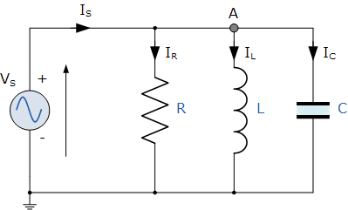
In the above parallel RLC circuit, we can see that the supply voltage, V_{S} is common to all three components whilst the supply current I_{S} consists of three parts. The current flowing through the resistor (I_{R}), the current flowing through the inductor (I_{L}) and the current through the capacitor (I_{C}).
But the current flowing through each branch and therefore each component will be different to each other and to the supply current, I_{S}. The total current drawn from the supply will not be the mathematical sum of the three individual branch currents but their vector sum.
Like the series RLC circuit, we can solve this circuit using the phasor or vector method but this time the vector diagram will have the voltage as its reference with the three current vectors plotted with respect to the voltage. The phasor diagram for a parallel RLC circuit is produced by combining together the three individual phasors for each component and adding the currents vectorially.

Since the voltage across the circuit is common to all three circuit elements we can use this as the reference vector with the three current vectors drawn relative to this at their corresponding angles. The resulting vector I_{S} is obtained by adding together two of the vectors, I_{L} and I_{C} and then adding this sum to the remaining vector I_{R}. The resulting angle obtained between V and I_{S} will be the circuits phase angle as shown below.
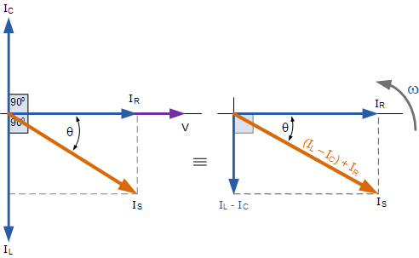
Circuit Diagram:
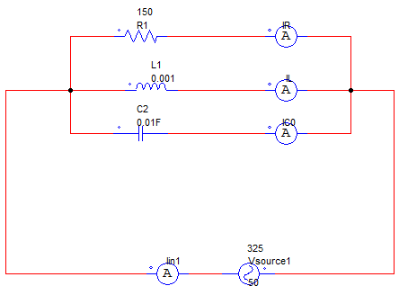
Output Waveform:
Sr. No. | Name | Waveform
1 | Supply  Voltage
2 | Supply  Current
3 | Current Through  R
4 | Current Through  L
5 | Current Through  C

Conclusion:
___________________________________________________________________________________________________________________________________________________________________________________________________________________________________________________________________________________________________________________________________________________________________________________________________________________________________________________________________________________________________________________________________________________________________________________________________________________________________________________________________________________________________
Questions:
- What will happen if value of resistance is increased?
________________________________________________________________________________________________________________________________________
- What will happen if value of inductor is increased?
______________________________________________________________________________________________________________________________________
- What will happen if value of capacitor is increased?
______________________________________________________________________________________________________________________________________

Experiment – 13
Aim: Simulate basic logic gates.
- AND Gate
- OR Gate
- NOT Gate
Objective:
After completing this experiment, you will be able to:
- Simulate Basic Logic Gates
Apparatus:
- Computer System with PSIM software.

- AND Gate

Circuit Diagram:
Truth Table:
A | B | Y=A×B
0 | 0
0 | 1
1 | 0
1 | 1

- OR Gate

Circuit Diagram:
Truth Table:
A | B | Y=A+B
0 | 0
0 | 1
1 | 0
1 | 1

- NOT Gate

Circuit Diagram:
Truth Table:
A | Y
0
1

Conclusion:
___________________________________________________________________________________________________________________________________________________________________________________________________________________________________________________________________________________________________________________________________________________________________________________________________________________________________________________________________________________________________________________________________________________________________________________________________________________________________________________________________________________________________

Experiment – 14
Aim: Using Simulation prove De Morgan’s Theorem.
Objective:
After completing this experiment, you will be able to:
- Simulate and prove the De Morgan’s Theorem
Apparatus:
- Computer System with PSIM software.
Theory:
Boolean Algebra uses a set of laws and rules to define the operation of a digital logic circuit with “0’s” and “1’s” being used to represent a digital input or output condition. Boolean Algebra uses these zeros and ones to create truth tables and mathematical expressions to define the digital operation of a logic AND, OR and NOT (or inversion) operations as well as ways of expressing other logical operations such as the XOR (Exclusive-OR) function.
While George Boole’s set of laws and rules allows us to analyse and simplify a digital circuit, there are two laws within his set that are attributed to Augustus DeMorgan (a nineteenth century English mathematician) which views the logical NAND and NOR operations as separate NOT AND & NOT OR functions respectively.
De Morgan’s Theorems are basically two sets of rules or laws developed from the Boolean expressions for AND, OR and NOT using two input variables, A and B. These two rules or theorems allow the input variables to be negated and converted from one form of a Boolean function into an opposite form.
De Morgan’s First Theorem:
DeMorgan’s First theorem proves that when two (or more) input variables are AND’ed and negated, they are equivalent to the OR of the complements of the individual variables. Thus the equivalent of the NAND function and is a negative-OR function proving that:
$$\overline{A.B}=\overline{A}+\overline{B}$$
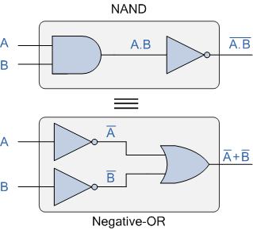
De Morgan’s Second Theorem:
De Morgan’s Second theorem proves that when two (or more) input variables are OR’ed and negated, they are equivalent to the AND of the complements of the individual variables. Thus the equivalent of the NOR function and is a negative-AND function proving that:
$$\overline{A+B}=\overline{A}.\overline{B}$$
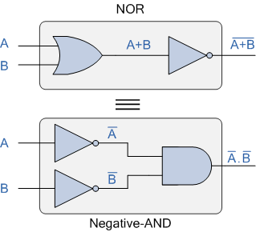
Circuit Diagram:

Truth Table:
A | B | A+B | $$\overline{A+B}$$ | A*B | $$\overline{A*B}$$ | $$\overline{A}$$ | $$\overline{B}$$ | $\overline{A}$.$\overline{B}$
0 | 0
1 | 0
0 | 1
1 | 1

Conclusion:
___________________________________________________________________________________________________________________________________________________________________________________________________________________________________________________________________________________________________________________________________________________________________________________________________________________________________________________________________________________________________________________________________________________________________________________________________________________________________________________________________________________________________

Experiment – 15
Aim: Using simulations prove that NAND gate is universal gate.
Objective:
After completing this experiment, you will be able to:
- Simulate and prove that NAND gate is universal gate
Apparatus:
- Computer System with PSIM software.
Theory:
The NAND gate is called a universal gate because combinations of it can be used to accomplish all the basic functions as follows.
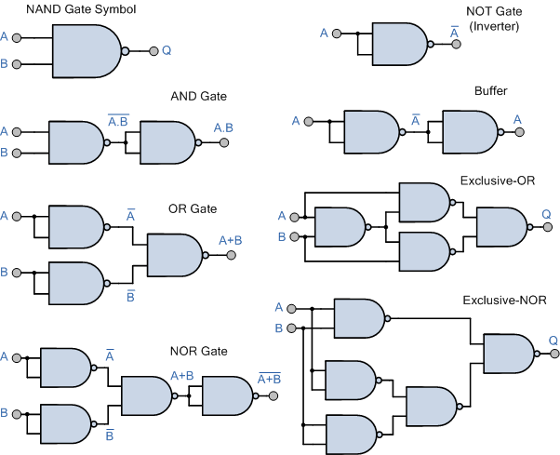

Circuit Diagram:

Truth Table:

Conclusion:
___________________________________________________________________________________________________________________________________________________________________________________________________________________________________________________________________________________________________________________________________________________________________________________________________________________________________________________________________________________________________________________________________________________________________________________________________________________________________________________________________________________________________

Experiment – 16
Aim: Using simulations prove that NOR gate is universal gate.
Objective:
After completing this experiment, you will be able to:
- Simulate and prove that NOR gate is universal gate
Apparatus:
- Computer System with PSIM software.
Theory:
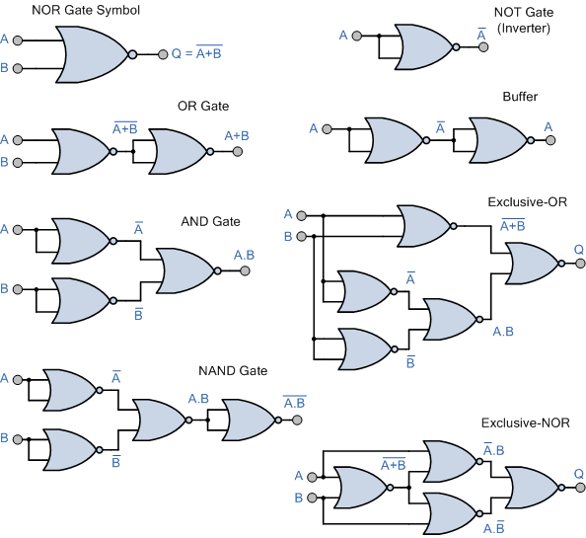

Circuit Diagram:

Truth Table:

Conclusion:
___________________________________________________________________________________________________________________________________________________________________________________________________________________________________________________________________________________________________________________________________________________________________________________________________________________________________________________________________________________________________________________________________________________________________________________________________________________________________________________________________________________________________

Experiment – 17
Aim: Using simulations prove half added and full adder circuit.
Objective:
After completing this experiment, you will be able to:
- Simulate half adder and full adder circuit
Apparatus:
- Computer System with PSIM software.
Theory:
Half adder:
With the help of half adder, we can design circuits that are capable of performing simple addition with the help of logic gates.
Let us first take a look at the addition of single bits.

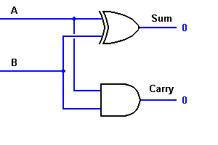
Full adder:
This type of adder is a little more difficult to implement than a half-adder. The main difference between a half-adder and a full-adder is that the full-adder has three inputs and two outputs.
The first two inputs are A and B and the third input is an input carry designated as CIN. When full adder logic is designed we will be able to string eight of them together to create a byte-wide adder and cascade the carry bit from one adder to the next.
The output carry is designated as COUT and the normal output is designated as S. Take a look at the truth-table.

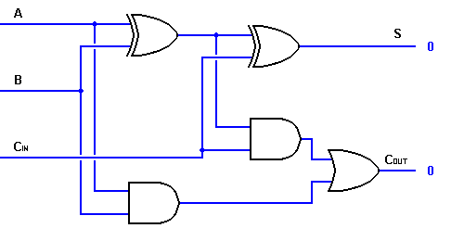

Circuit Diagram:
- Half adder:

- Full adder:

Truth Table:
- Half adder:

INPUTS OUTPUTS
A B SUM CARRY
0 0
0 1
1 0
1 1

- Full adder:

INPUTS OUTPUTS
A B CIN COUT S
0 0 0
0 0 1
0 1 0
0 1 1
1 0 0
1 0 1
1 1 0
1 1 1

Conclusion:
___________________________________________________________________________________________________________________________________________________________________________________________________________________________________________________________________________________________________________________________________________________________________________________________________________________________________________________________________________________________________________________________________________________________________________________________________________________________________________________________________________________________________

Experiment – 18
Aim: Using simulations prove half subtractor and full subtractor.
Objective:
After completing this experiment, you will be able to:
- Simulate half subtractor and full subtractor
Apparatus:
- Computer System with PSIM software.
Theory:
Half subtractor:
The half subtractor is a combinational circuit which is used to perform subtraction of two bits. It has two inputs, the minuend X and subtrahend Y and two outputs the difference D and borrows out B_{out}.

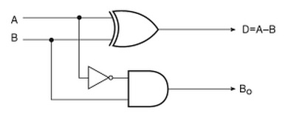
Full subtractor:
The full subtractor is a combinational circuit which is used to perform subtraction of three input bits: the minuend X, subtrahend Y, and borrow in B_{in}. The full subtractor generates two output bits: the difference D and borrow out B_{out}.

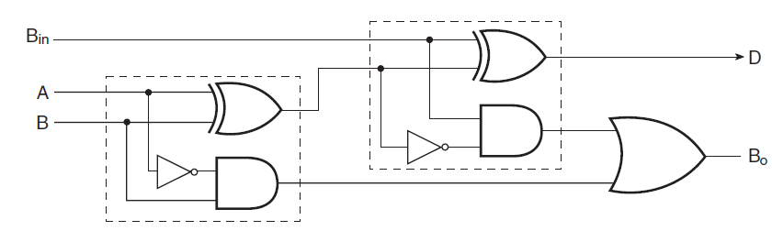

Circuit Diagram:
- Half subtractor:

- Full subtractor:

Truth Table:
- Half subtractor:
Inputs |  | Outputs
X | Y | D | B_{out}
0 | 0
0 | 1
1 | 0
1 | 1

- Full subtractor:

Inputs |  |  | Outputs
X | Y | B_{in} | D | B_{out}
0 | 0 | 0
0 | 0 | 1
0 | 1 | 0
0 | 1 | 1
1 | 0 | 0
1 | 0 | 1
1 | 1 | 0
1 | 1 | 1

Conclusion:
__________________________________________________________________________________________________________________________________________________________________________________________________________________________________________________________________________________________________________________________________________________________________________________________________________________________________________________________________________________________________________________________________________________________________________________________________________________________________________________________________________________________________

Experiment – 19
Aim: Simulate stair case wiring circuit.
Objective:
After completing this experiment, you will be able to:
- Simulate stair case wiring circuit.
Apparatus:
- Computer System with PSIM software.
Theory:
In stair case wiring we have to control a single bulb from two different places by using two 2-way switches.
Consider following 2-way switch wiring diagram which has been used to control a bulb in staircase. The schematic shows that circuit is completed and bulb is ON. Suppose you want to OFF the bulb from the upper switch at top of stair (upper portion of staircase) simply Switch OFF the switch then circuit will break and the bulb will be OFF. To switch ON the bulb again, just switch ON the same switch at upper portion of staircase. In other words you can OFF and ON bulb from upper switch at the top of stair. Obviously, you can perform the same operation from the bottom switches installed in staircase.
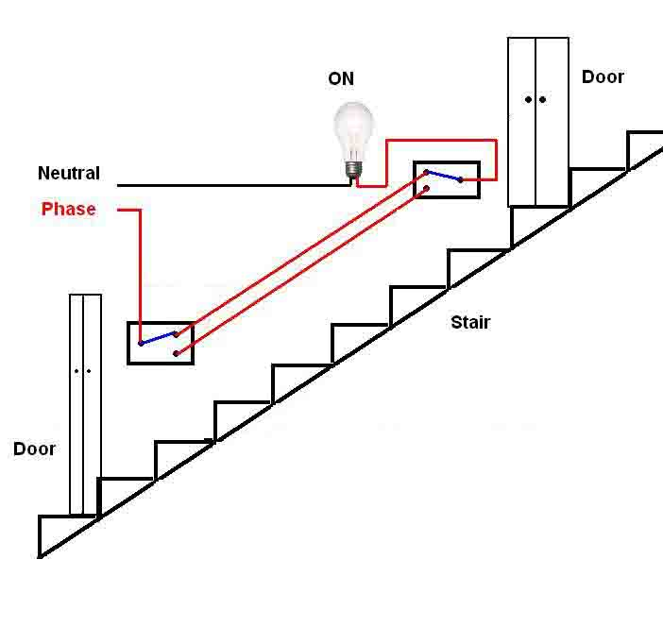
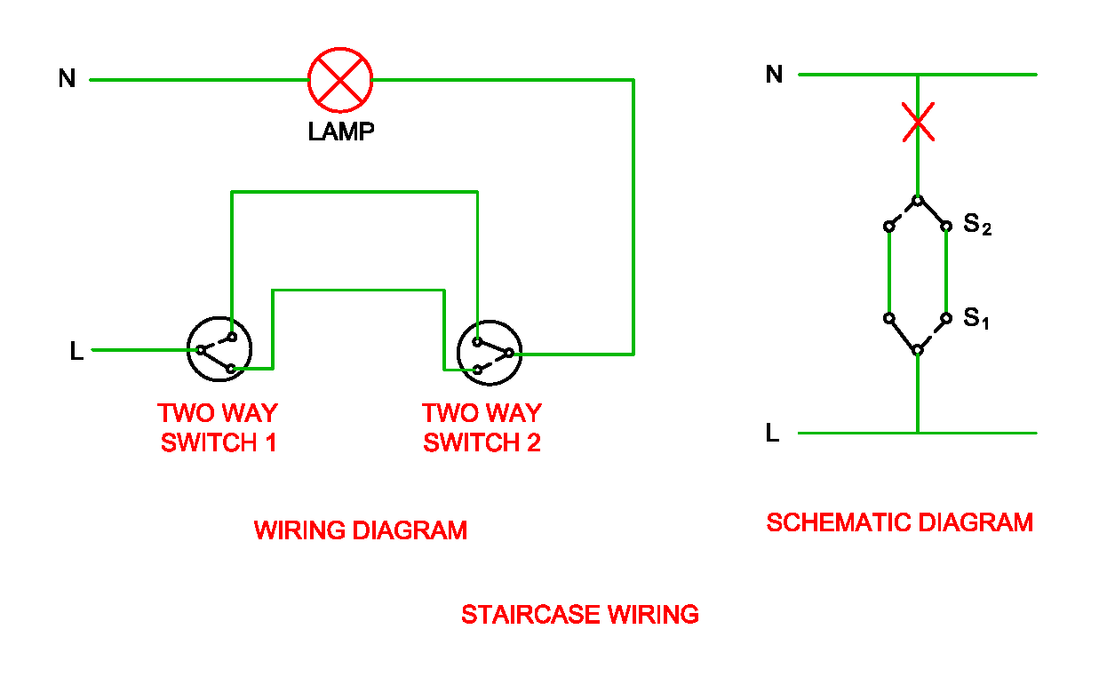

Circuit Diagram:

Conclusion:
__________________________________________________________________________________________________________________________________________________________________________________________________________________________________________________________________________________________________________________________________________________________________________________________________________________________________________________________________________________________________________________________________________________________________________________________________________________________________________________________________________________________________

Experiment – 20
Aim: Develop P.C.B. layout for a given electrical circuit using proteus software.
- 5V Power Supply
- Water Level Indicator
Objective:
After completing this experiment, you will be able to:
- Use Proteus software for circuit simulations
- Develop P.C.B layout of 5V power supply
- Develop P.C.B layout of Water Level Indicator
Apparatus:
- Computer System with Proteus software.
Circuit Diagram:
- 5V Power Supply
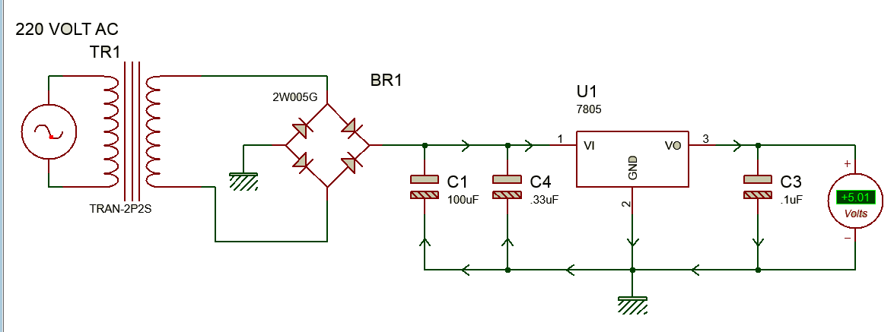
P.C.B. Layout:

- Water Level Indicator
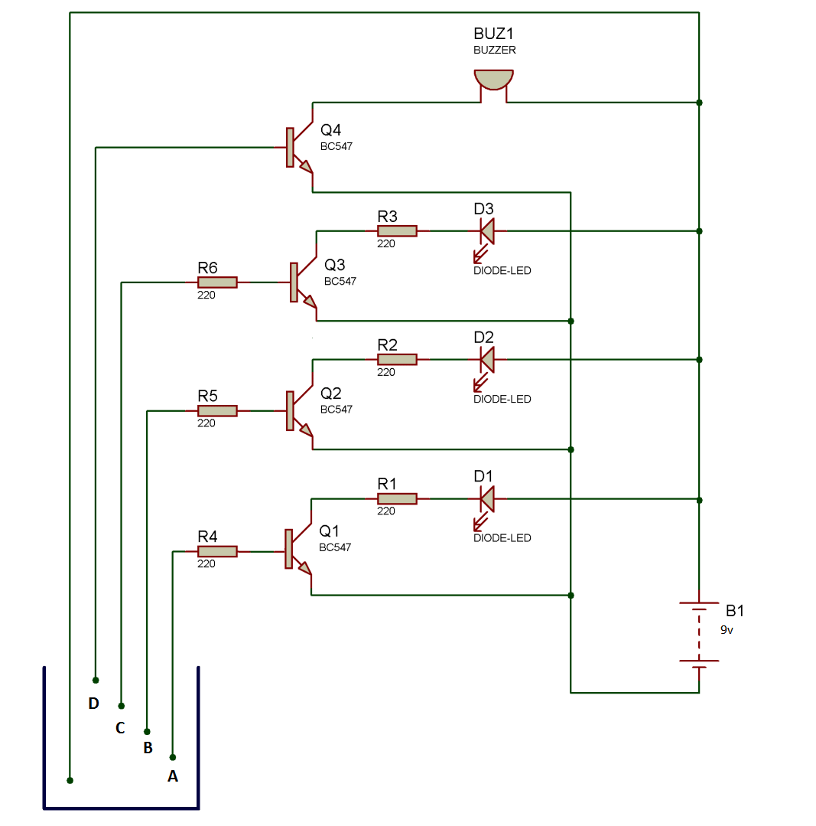

P.C.B. Layout:

Conclusion:
___________________________________________________________________________________________________________________________________________________________________________________________________________________________________________________________________________________________________________________________________________________________________________________________________________________________________________________________________________________________________________________________________________________________________________________________________________________________________________________________________________________________________

Questions:
- Why we use the PCB?
________________________________________________________________________________________________________________________________________________________________________________________________________________________________________________________________________________
- State the PCB Design software available in market.
________________________________________________________________________________________________________________________________________

